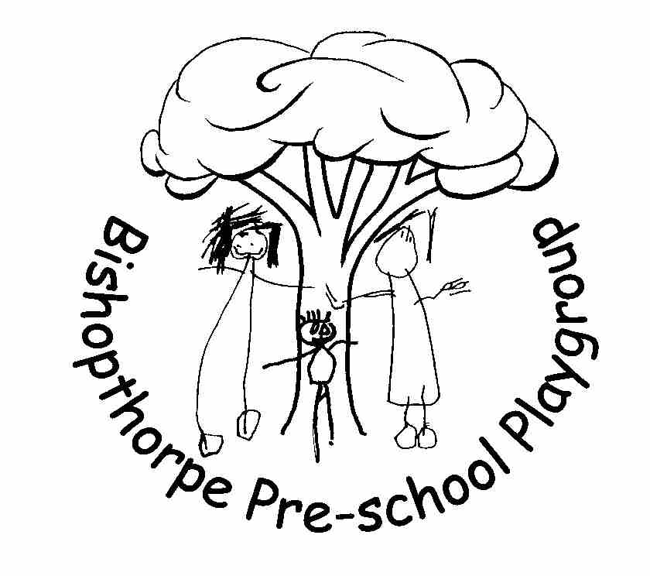
Sustainability Policy

Safeguarding and Welfare Requirements
3.2 Providers must take all necessary steps to keep children safe and well

Safeguarding and Welfare Requirements - Safety and Suitability of Premises, Environment and Equipment

3.53 Providers must ensure that their premises, including outdoor spaces, are fit for purpose.
3.54 Providers must take reasonable steps to ensure the safety of children, staff and others on the premises.
3.63 Providers must have a clear and well-understood policy, and procedure, for assessing and risks to children’s safety, and review risk assessments regularly.

Statement of Intent

As an education and care setting, we can encourage and increase awareness of environmental responsibilities and implement practices that contribute to a sustainable future. Children can be supported to become environmentally responsible and show respect for the environment. Environmentally sustainable practices should be embedded into the operations of Bishopthorpe Preschool Playgroup and involve staff, children and families in order to be successful.

Background

Current research confirms that experiences in the early years help establish lifelong behaviour and values, and this reinforces the need for sustainability education to be included in early childhood education. It is important for children to understand their place in the world and the role that they can play in protecting the environment. Children should learn to be environmentally responsible and be empowered to make a difference, and this learning should not wait until the ‘formal education’ of primary school.

Aim

In recognising that early childhood is an important time for learning about the environment, the environmental education efforts at the Playgroup aim to:

- Provide the children and their families with an appreciation of the natural environment and an understanding of how to reduce our impacts on that environment.

- Minimise the environmental impacts of the Playgroup itself (including both the site and our practices)

Practices

Our sustainability objectives will be achieved through a variety of methods, including:

- Staff will make sustainable practices at Playgroup part of the daily routine, and recognise that they are role modelling these for the children. These include:
- Recycling
- Gardening
- Energy conservation
- Water conservation
- Sustainable equipment purchases

- When appropriate, staff will discuss sustainable practices with the children and why we do this. Age appropriate language will be used, such as “being kind to the earth”.

- Staff will be able to provide information to families on the sustainable practices that are implemented at Playgroup, and encourage the application of these practices in the home environment.

- Ideas on improving sustainability should be shared at staff meetings, and any methods implemented can be shared in the half-termly newsletter, on the ‘eco-board’, and on social media.

- Use a composting bin to reduce food waste in the Playgroup.

- Aim to purchase equipment that is eco-friendly where possible. Staff will reduce the amount of plastic and disposable equipment they purchase and select materials that are made of natural materials and fibres.

- Seek to embed sustainable practice in playgroup. The concepts of “reduce, re-use and recycle” will become part of everyday practice for both children and staff to build lifelong attitudes towards sustainable practices.

- Use Forest School sessions to allow the children to experience first hand exploration of the local natural environment and learn how to care for and respect the world around us.

Eco-Schools Award

As part of our commitment to the environment, we are enrolled as an ‘Eco-School’. This is an international initiative aimed at engaging schools and students in reducing their environmental impact, managed in the UK by the ‘Keep Britain Tidy’ campaign.

The Eco-committee, which meets half-termly, discuss ways in which Playgroup could become more environmentally friendly. Many of the environmental improvements have been initiated by the Eco-committee, named by the children as the ‘Super-Bugs’. The Eco-committee has been successful in achieving their Green Flag (gold) award for Playgroup.

Actions include ending the use of plastic straws, doing weekly litter-picks, making signs to remind everyone to turn off taps, building an ‘insect hotel’, setting up a compost bin, having special recycling bins for crisp packets and pens and much more.

This Policy was adopted at a meeting of Bishopthorpe Preschool Playgroup
Held on ___________________
Signed on behalf of Bishopthorpe Preschool Playgroup ___________________
Role of Signatory Chairperson
Date of next substantive review August 2020

