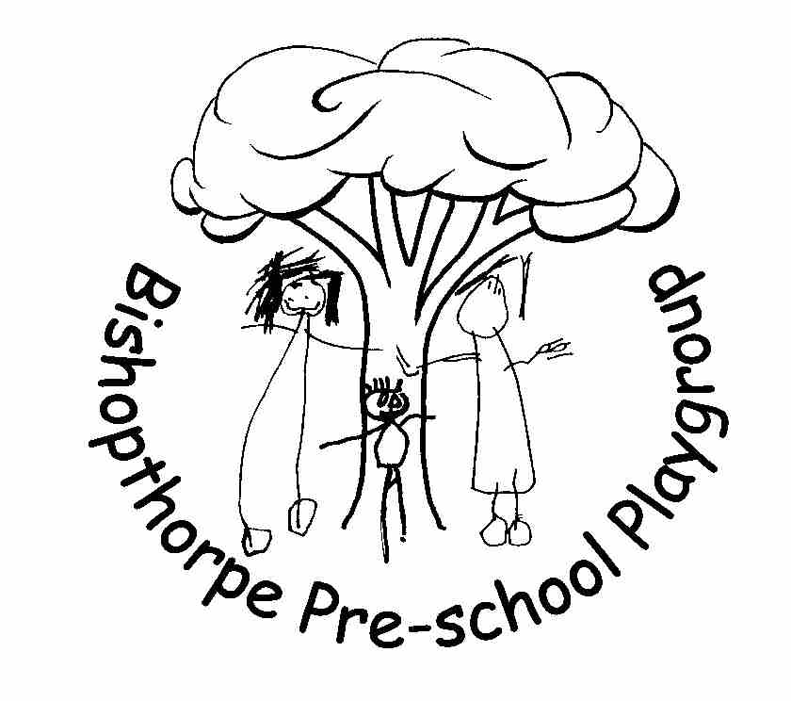
Forest School Policy
3.1. Children learn best when they are healthy, safe and secure, when their individual needs are met, and when they have positive relationships with the adults caring for them. The safeguarding and welfare requirements, specified in this section, are designed to help providers create high quality settings which are welcoming, safe and stimulating, and where children are able to enjoy learning and grow in confidence.

3.2. Providers must take all necessary steps to keep children safe and well. The requirements in this section explain what early years providers must do to: safeguard children; ensure the suitability of adults who have contact with children; promote good health; manage behaviour; and maintain records, policies and procedures.

Safeguarding and Welfare Requirements - Outings

3.66. Children must be kept safe while on outings. Providers must assess the risks or hazards which may arise for the children, and must identify the steps to be taken to remove, minimise and manage those risks and hazards. The assessment must include consideration of adult to child ratios. The risk assessment does not necessarily need to be in writing; this is for providers to judge

Safeguarding and Welfare Requirements - Safety and suitability of premises, environment and equipment

3.55. Providers must ensure that their premises, including overall floor space and outdoor spaces, are fit for purpose and suitable for the age of children cared for and the activities provided on the premises. Providers must comply with requirements of health and safety legislation (including fire safety and hygiene requirements).

3.56. Providers must take reasonable steps to ensure the safety of children, staff and others on the premises in the case of fire or any other emergency, and must have an emergency evacuation procedure. Providers must have appropriate fire detection and control equipment (for example, fire alarms, smoke detectors, fire blankets and/or fire extinguishers) which is in working order. Fire exits must be clearly identifiable, and fire doors must be free of obstruction and easily opened from the inside.

Statement of Intent

At Bishopthorpe Preschool Playgroup children learn about the natural world, its animals and other living organisms, as part of the Early Years Foundation Stage. Forest School builds upon the themes in the EYFS and allows for further exploration of the natural world. This may include contact with animals, plants or other living creatures at the Forest School site. We aim to ensure that this is in accordance with current relevant hygiene and safety controls.

Aim

Forest School provides unique experiences for children. It gives them the opportunity to learn outside the classroom with the freedom to explore the ever changing natural world. Forest School aims to build on a child’s innate motivation and positive attitude, offering them the opportunities to take risks, work co-operatively, make choices and initiate learning for themselves.

During Forest School sessions, the children will be taught to use a range of tools beginning with a vegetable peeler and working up to a bow saw. We have all the relevant risk assessments in place and we will only introduce tools when the children are capable and ready.

The use of fire is embedded in Forest School practice, primarily for cooking but also for a source of heat in cold weather. We will actively encourage the children to be involved in the process and when and only when they can demonstrate they have the understanding and capability; will we allow them to help build and light the fire with support from the Forest School Leader.

Session information

The Forest School sessions will run for either a morning or an afternoon session. The session will be approximately 2.5 hours in length which will include getting changed in and out of the protective waterproof clothing. The Forest School Leader and Setting Manager will select a group of between 6-8 children who will attend the Forest School every week for a half term. Parental consent will be sought and permission slips signed before any child can take in Forest School.

Ratios and staffing

The Forest School Leader will always be supported by an Assistant. The Forest School Leader and Assistant will be fully DBS checked and hold current paediatric first aid qualifications. In addition, the Forest School Leader holds a full outdoor first aid qualification.
Due to the nature of Forest School, it is paramount that a high adult to child ratio is maintained. We have decided that we work to a maximum of a 1:4 ratio.
Ratios when using tools this will be on a 1:1 basis with the Forest School Leader and will then be reassessed as the children’s coincidence and capability increases.

Cost

To allow Bishopthorpe Preschool Playgroup to offer Forest School, we need to employ additional staff on the relevant sessions. It is important that we maintain a high staff to child ratio, especially when we are using tools and building fires. We therefore kindly ask for a contribution of £40.00 towards the half termly programme of sessions.

Environmental Considerations

Forest School has environmental awareness at the heart of its ethos. The Forest School session will help the children to understand, appreciate and care for the natural environment. If any additional resources are taken down to the site, these will be eco friendly, sustainable or made from recycled materials wherever possible.

Health and Safety Considerations

The Forest School programme will support young children to develop responsibility for themselves and others. It will encourage children to be aware of risk and promotes risk management strategies, with the hope that the children will start to consider the impact of their actions on the environment, themselves and on others.
Extensive risk assessments have been conducted and copies are available on request.
As the environment is constantly changing and activities may be spontaneous, the Forest School Leader may assess risks ‘in the moment’ and any risk assessments will be amended accordingly if required.

Safeguarding children and adults at Forest School

Forest School Leaders and staff should regard their duty of care when working with the children as extremely important. To ensure all individuals (children, staff and parent helpers) are safe and protected, The Forest School Leader will ensure

- Everyone involved in Forest School is fully briefed on health and safety and have read and understood the risk assessment for the site and activities.

- Staff are aware of all the relevant playgroup policies and ensure that they adhere to the guidance contained in them.

- That if any personal protective equipment is required that it is available and suitable for the users.

- Confidentiality is maintained at all times. Sensitive information such as personal contact details will be kept in the lockable blue filing cabinet. The information will only be accessed by the Forest School Leader and her assistants.

Toileting whilst at the Forest School Site

Children will be encouraged to use the toilet before beginning the Forest School session.

If the children do require the toilet whilst at the site, the toileting tent will be set up to facilitate toileting needs, with the emphasis on maintaining privacy.
The tent will home a small portable potty chair for the children to use. The children will be encouraged to access the toileting facilities independently,

Toilet roll will be made available and hand wipes to maintain good hygiene practices. The Forest School Leader or Assistant will clean the potty with antibacterial wipes when and as required.

Urine will be disposed of in the allocated area on the site and if children need a poo, this will be bagged in a biodegradable nappy sack and disposed of once back at Playgroup in the outside bin.

If a child’s clothing becomes soiled, a phone call with be made to playgroup to collect the child and change clothing if appropriate.

Considerations for Equality and Inclusion

In Forest School sessions all persons should be treated equally.

We aim to and are committed to:

- providing a secure environment in which children can flourish and in which all contributions are valued.

- include and value the contribution of all children and adults to our understanding of equality and diversity.

- Make all Forest School activities fully inclusive.

Cancellation Procedure

There may be times when Forest School sessions have to be cancelled due to unforeseen circumstances. These may be-

- Staff illness – which prevents staff/child ratios being met.

- Severe weather conditions.

- Any situation that poses a health and safety risk.

In the event of this situation arising the Forest School Leader will advise the children and where necessary the parents that the session will not be running.

Insurance

Insurance for activities within Forest School are included within Playgroups existing insurance policy.
Related policies
Policies that are adhered to within Forest School sessions are as follows;
- Health and Safety Policy
- Fire Safety and Emergency Evacuation policy
- First Aid and dealing with accidents policy
- Managing children with allergies and infections policy
- Administering medicine policy
- Missing child policy
- Behaviour Management policy
- Outings and Visits policy
- Special Educational Needs and Disabilities policy
- Disclosure and Barring Service (DBS) Policy
- Valuing Diversity and promoting Equality Policy
- Maintaining Children‘s Safety and Security Policy
- Safeguarding Children Policy including Extremism and the Prevent Duty

This Policy was adopted at a meeting of Bishopthorpe Preschool Playgroup
Held on ___________________
Signed on behalf of Bishopthorpe Preschool Playgroup ___________________
Role of Signatory Chairperson
Date of next substantive review September 2022

